Dear friends, family and sponsors,

I am wishing you a happy summer from Honduras, hoping you enjoy your vacations if you get any!
I am writing this letter to give some news and hoping you will enjoy being part of some anecdotes, but also to ask you to pray for the next four months, as Tina, the director, is away in Spain for that time, and the leadership of the Children´s home falls in my hands, as well as my co-worker Denia, a Honduran lady who is in charge of administration and accounting.
Pray for wisdom and discernment when it comes to decision making and crisis intervention!
We have been so blessed in this past year, with volunteers, new donors, and people who support us, that have confirmed every time that this ministry, in particular these children, have a very special place in the heart of God. It may sound silly, but every time the power goes out and we have the possibility of turning on our electricity generator, it’s a symbol for me, that whatever difficulty or darkness lies for us out there, there is a solution, and God has his response to every hardship. He puts light where there is darkness, especially when his children need it.

Most of you, (if not everyone) have heard me speak of my dear Cristhian, my little 2 year old treasure who just seems like a gift from God to spread joy and laughter wherever he goes (well, he does act like a little earthquake every once in a while, but he´s precious all the way). He is no longer the “babyiest” of them all. We have a 10 month old baby, Alex, who arrived at the age of four months, (also with many health issues, we now know that this will be a major focus on most of our young babies), and we also have a 21 month old baby who was also with us since she was a couple of months old, Josseline.
Recently our little Josseline had to be hospitalized for four days, as she had an intestinal obstruction and her intestine had twisted (kind of making the form of a bow). We were told she was going to need surgery but thankyou Lord, she didn´t. The doctors were able to treat her so that her intestine would unswell, and it “untwisted” by itself. We are very thankful for that, as it is not a procedure one wishes over any baby!

We also have a family of 3 siblings, Dilcia, Marlon, and Karla, who arrived last February. Their age are approximately 2, 5, and 7, but we don´t know, since they have not been registered, in other words, “they don´t exist”. I am sharing this little part of their story because it is the reality of many children here in Honduras, who end up being abandoned and dying without ever “officially existing”.
Here in Siguatepeque, I was working alongside the Forensic doctor (who was also my French student) when we had cases like that or others that required some sort of forensic evaluation, and we used to be able to “fix” these things quickly, but unfortunately he is no longer here, so when I took the children to the forensic department at the “Ministerio Público”, there were two young ladies, who seemed more concerned about handling their walk in high heels then about the needs of the children. And eventually sent me to the City of San Pedro with my court ordered letter.
Our journey in San Pedro Sula (which, if you have heard in the news, has become one of the most dangerous cities in the world), was far from pleasant. First we had to go to the Morgue, because that is where the Forensics department is in that city (yes, trip to the morgue with 3 young children), there, they had their dental forensic evaluation and count up. Then, we had to cross the city to get to the Forensic Dr that does the age calification through things like size, weight, body development, etc. The problem is, this doctor is situated inside the Police “posta”, which is exactly the way you might have seen in the movies from this part of the world. Criminals coming in and out, some handcuffed, some not, some pushed and kicked around. You can sense evil, you can sense pain, and you can definitely smell, see and hear high amounts of suffering. From the “waiting hallway”, you can here a rape victim testifying about her assault, still in shock, while her assailant is apparently in the next room. Next to her, there is a domestic violence victim whose child (who is there with her) is a witness of the attempted murder, and next door, the attacker waits. There I stand (there is no chairs) with the youngest child in my arms and the other 2 both holding my hand, waiting for this to be over and getting as far as I can. After almost 2 hours of this we finally get our turn, and then we leave, to go to another part of town, the public Hospital, to get the x-rays done. Once in the hospital, we have to go through a corridor that says “no children aloud”, and I have to argue with the guard that if the x-rays are for the children, it is kind of crucial that they are there…. You can probably sense by now that what started off to be be a “let’s get these kids papers” mission now seems to be a series of frustrating, creepy, and unsettling events. Well, to finish the story, we end up getting access to the x-ray room, through a long hallway of people half naked laying on the floor, waiting for their turn to come, while the radiologist technicians were inside the room watching the soccer game.
I am waiting for their papers, and hoping to have them by the end of this year, so that the 2 older kids can be in school. Pray that the authorities and the bureaucracy speed up a little!

On the “up side”, things seem to be “flowing” well and positively. The kids are going to the AWANA program at my parents´church every Saturday, and enjoy this very much, the teens are going to youth group on Saturday nights, and were able to assist to a Christian youth camp last month. They all go together to Emmanuel church on Sundays, a church that has recently become involved in the discipleship of our children, which we are very happy about.
I am so proud about some of the accomplishments the children have made studying, graduating with excellency, (ok, from elementary school, but here, THIS IS a big deal). Indira and Lesbia are still in university and Jenny is next up, she will begin in August, she has decided she wants to study public accounting.

In a nutshell, this is it for now (yes, big nutshell).

Please keep praying for our safety, for our health (physical, emotional and spiritual). Last week two of my friends were kidnapped, one was released, but the other one, a famous reporter here in Honduras, is still missing. The last time he was seen alive was in the car, and the car was found with a lot of blood, teeth, and bullets. The media assumes he is dead, but his family and friends, we are still hoping for a miracle. He is a diabetic man with high blood pressure, and of course everyone is very worried. Anibal Barrows is a man who has been protesting corruption in all political levels, and criticizing the injustice and oppression of the “elite” towards the people. There is no such thing as freedom of press or freedom of expression here in Honduras. In this last presidential mandate, 27 reporters have been murdered.

Thanks to all of you who are praying and supporting me and the home. Thanks to all of you who care about what happens with these little ones. I apologize for not sending news more regularly, as I know many of you deserve that and much more.

Keep us in your prayers always,

Melodie

A little something I was reflecting on: Jesus knows what it´s like to be exposed, to be naked, to be beaten, to be abandoned, to be mocked, to be rejected, to be denied, to be hungry, to be thirsty, to be in pain, to be alone….. According to the gospels, Jesus went through all this and more. I find his words, in Mathew 25: 40 “whatever you do to one of these little ones you have done that to me” extremely powerful. Not only is he telling us to do good because it’s like doing good to Him, but he really does understand what these little ones have felt and needed. He doesn’t only understand through empathy, he understands through experience. So yes, let’s continue to take care of these little treasures, not only because we are doing it to Jesus, but because it’s what Jesus wants us to do. Because He KNOWS, and HE FEELS. And this makes me love Him more.

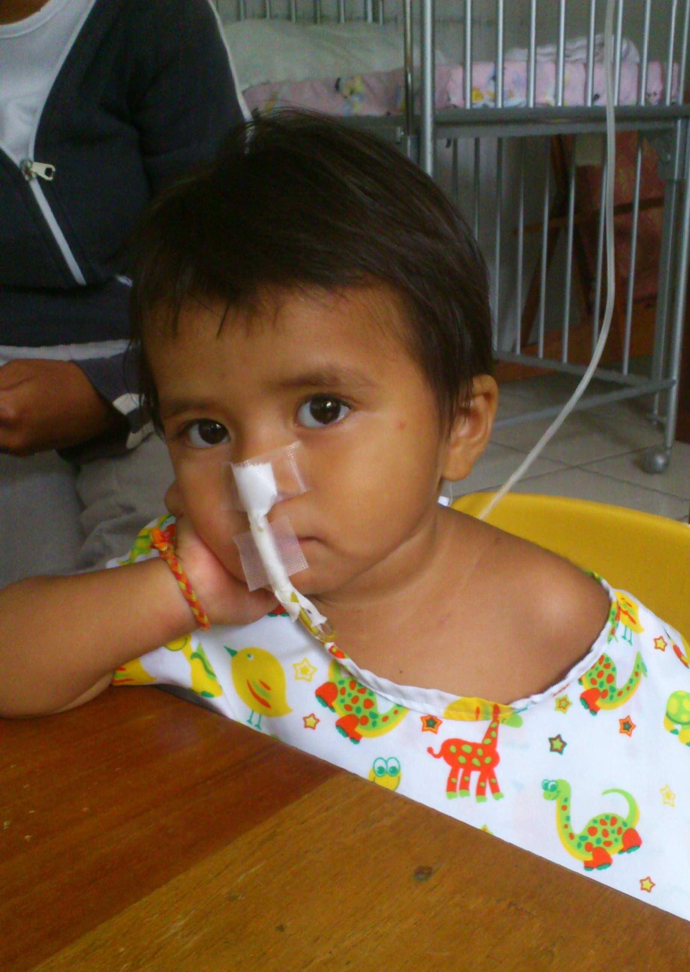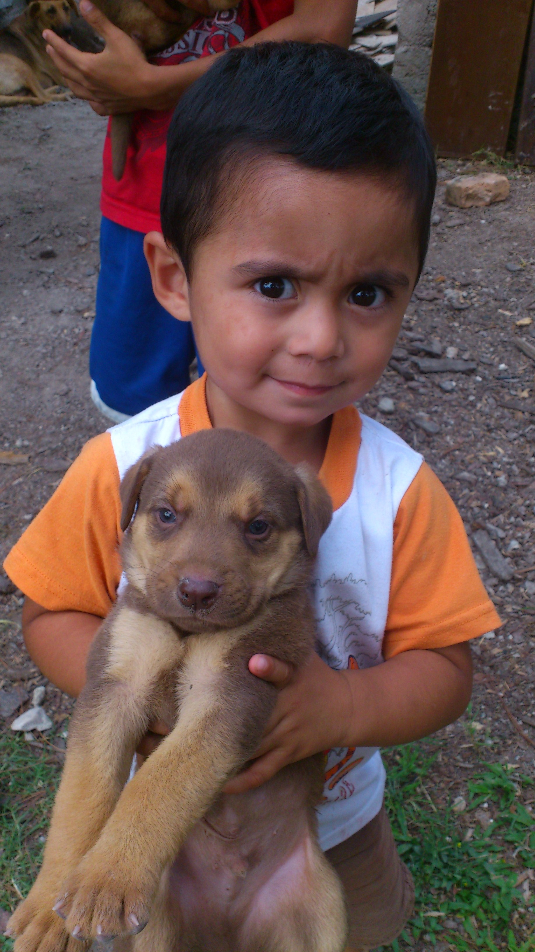
Little Josselin at the hospital Christian… being cute.

