The story behind this heartbreaking photo of a Syrian refugee family
Yahoo7 News
August 21, 2015, 8:07 am
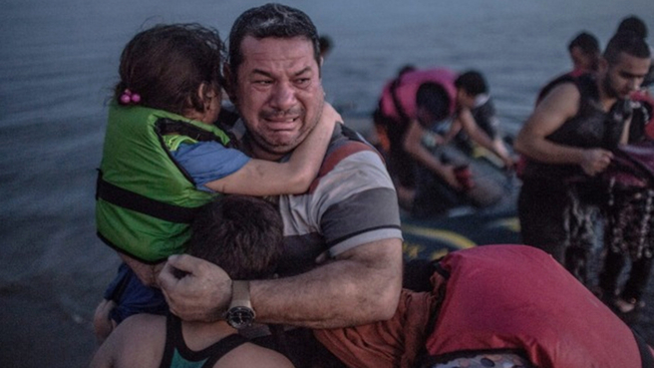
This photograph of Syrian refugee Laith Majid hugging his children after arriving on the Greek island of Kos has gone viral, Photo: Daniel Etter.
This is the incredible moment that sheer desperation gave way to tears of joy for a refugee family fleeing to safety of the Greek island of Kos.
The photograph of Lith Majid hugging his daughter and son after their rickety boat reached the sanctuary of safe shores, has struck a chord with thousands of people across the world since it was first published by the New York Times on Sunday.
Captured by freelance photographer Daniel Etter, the photo shows the incredible plight faced by asylum seekers.
"I might not be the most emotional person, but the father, Laith Majid, and his reaction when he and his family reached Greece still makes me cry,” Mr Etter wrote on his Facebook page.
Majid and his children were among 15 men, women and children who travelled across from the Turkish resort town of Bodrum on a flimsy rubber boat. A two-hour journey that reportedly cost them around $8,000.
"After more than two hours of driving the boat had lost air, water had leaked into it, the refugees were soaked when they arrived at the shore. They were then completely relieved to have arrived safely," the 34-year-old photographer told German-speaking news site Speigel.
"In that moment it all came at them together, the joy of having done it; the love for their family; the grief over what had happened," he said. Majid and his wife, a schoolteacher, left their home in the war-torn Syrian city of Deir Ezzor with their three children.
"She told me it took them a long time to decide whether to leave their home or not," Etter said.

https://au.news.yahoo.com/world/a/29314255/the-story-behind-this-heartbreaking-photo-of-a-syrian-refugee-family/

