It’s the Little Things

October 2016

Under the Southern Cross

**Curtis & Diane Steward Gospel Mission of South America** 1401 SW 21st Ave. Ft. Lauderdale, FL 33312 P.O. Box 150 St. Charles, ON P0M 2W0 509-992-8136 csteward@gmsa.org

**Sometimes** it’s the little things that can drag you down too:

* Visa issues, for Curtis in the U.S. and Diane in Canada – The need to extend our visa for Chile.
* Health issues, including Curtis’s bout of shingles.
* Insurance claims still unpaid.
* Distance from our families, especially the girls.
* Diane’s mom fell in her home about a month after the party and fractured her pelvis. She is recuperating. Curtis’s mom also broke some ribs recently.

**We appreciate your prayers.**

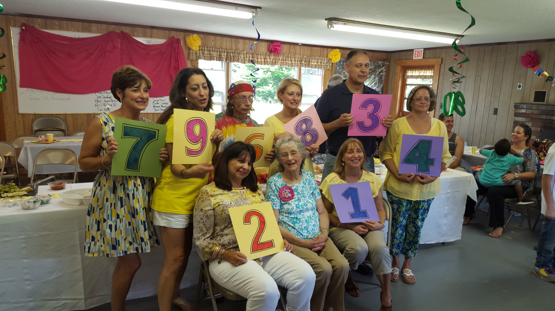

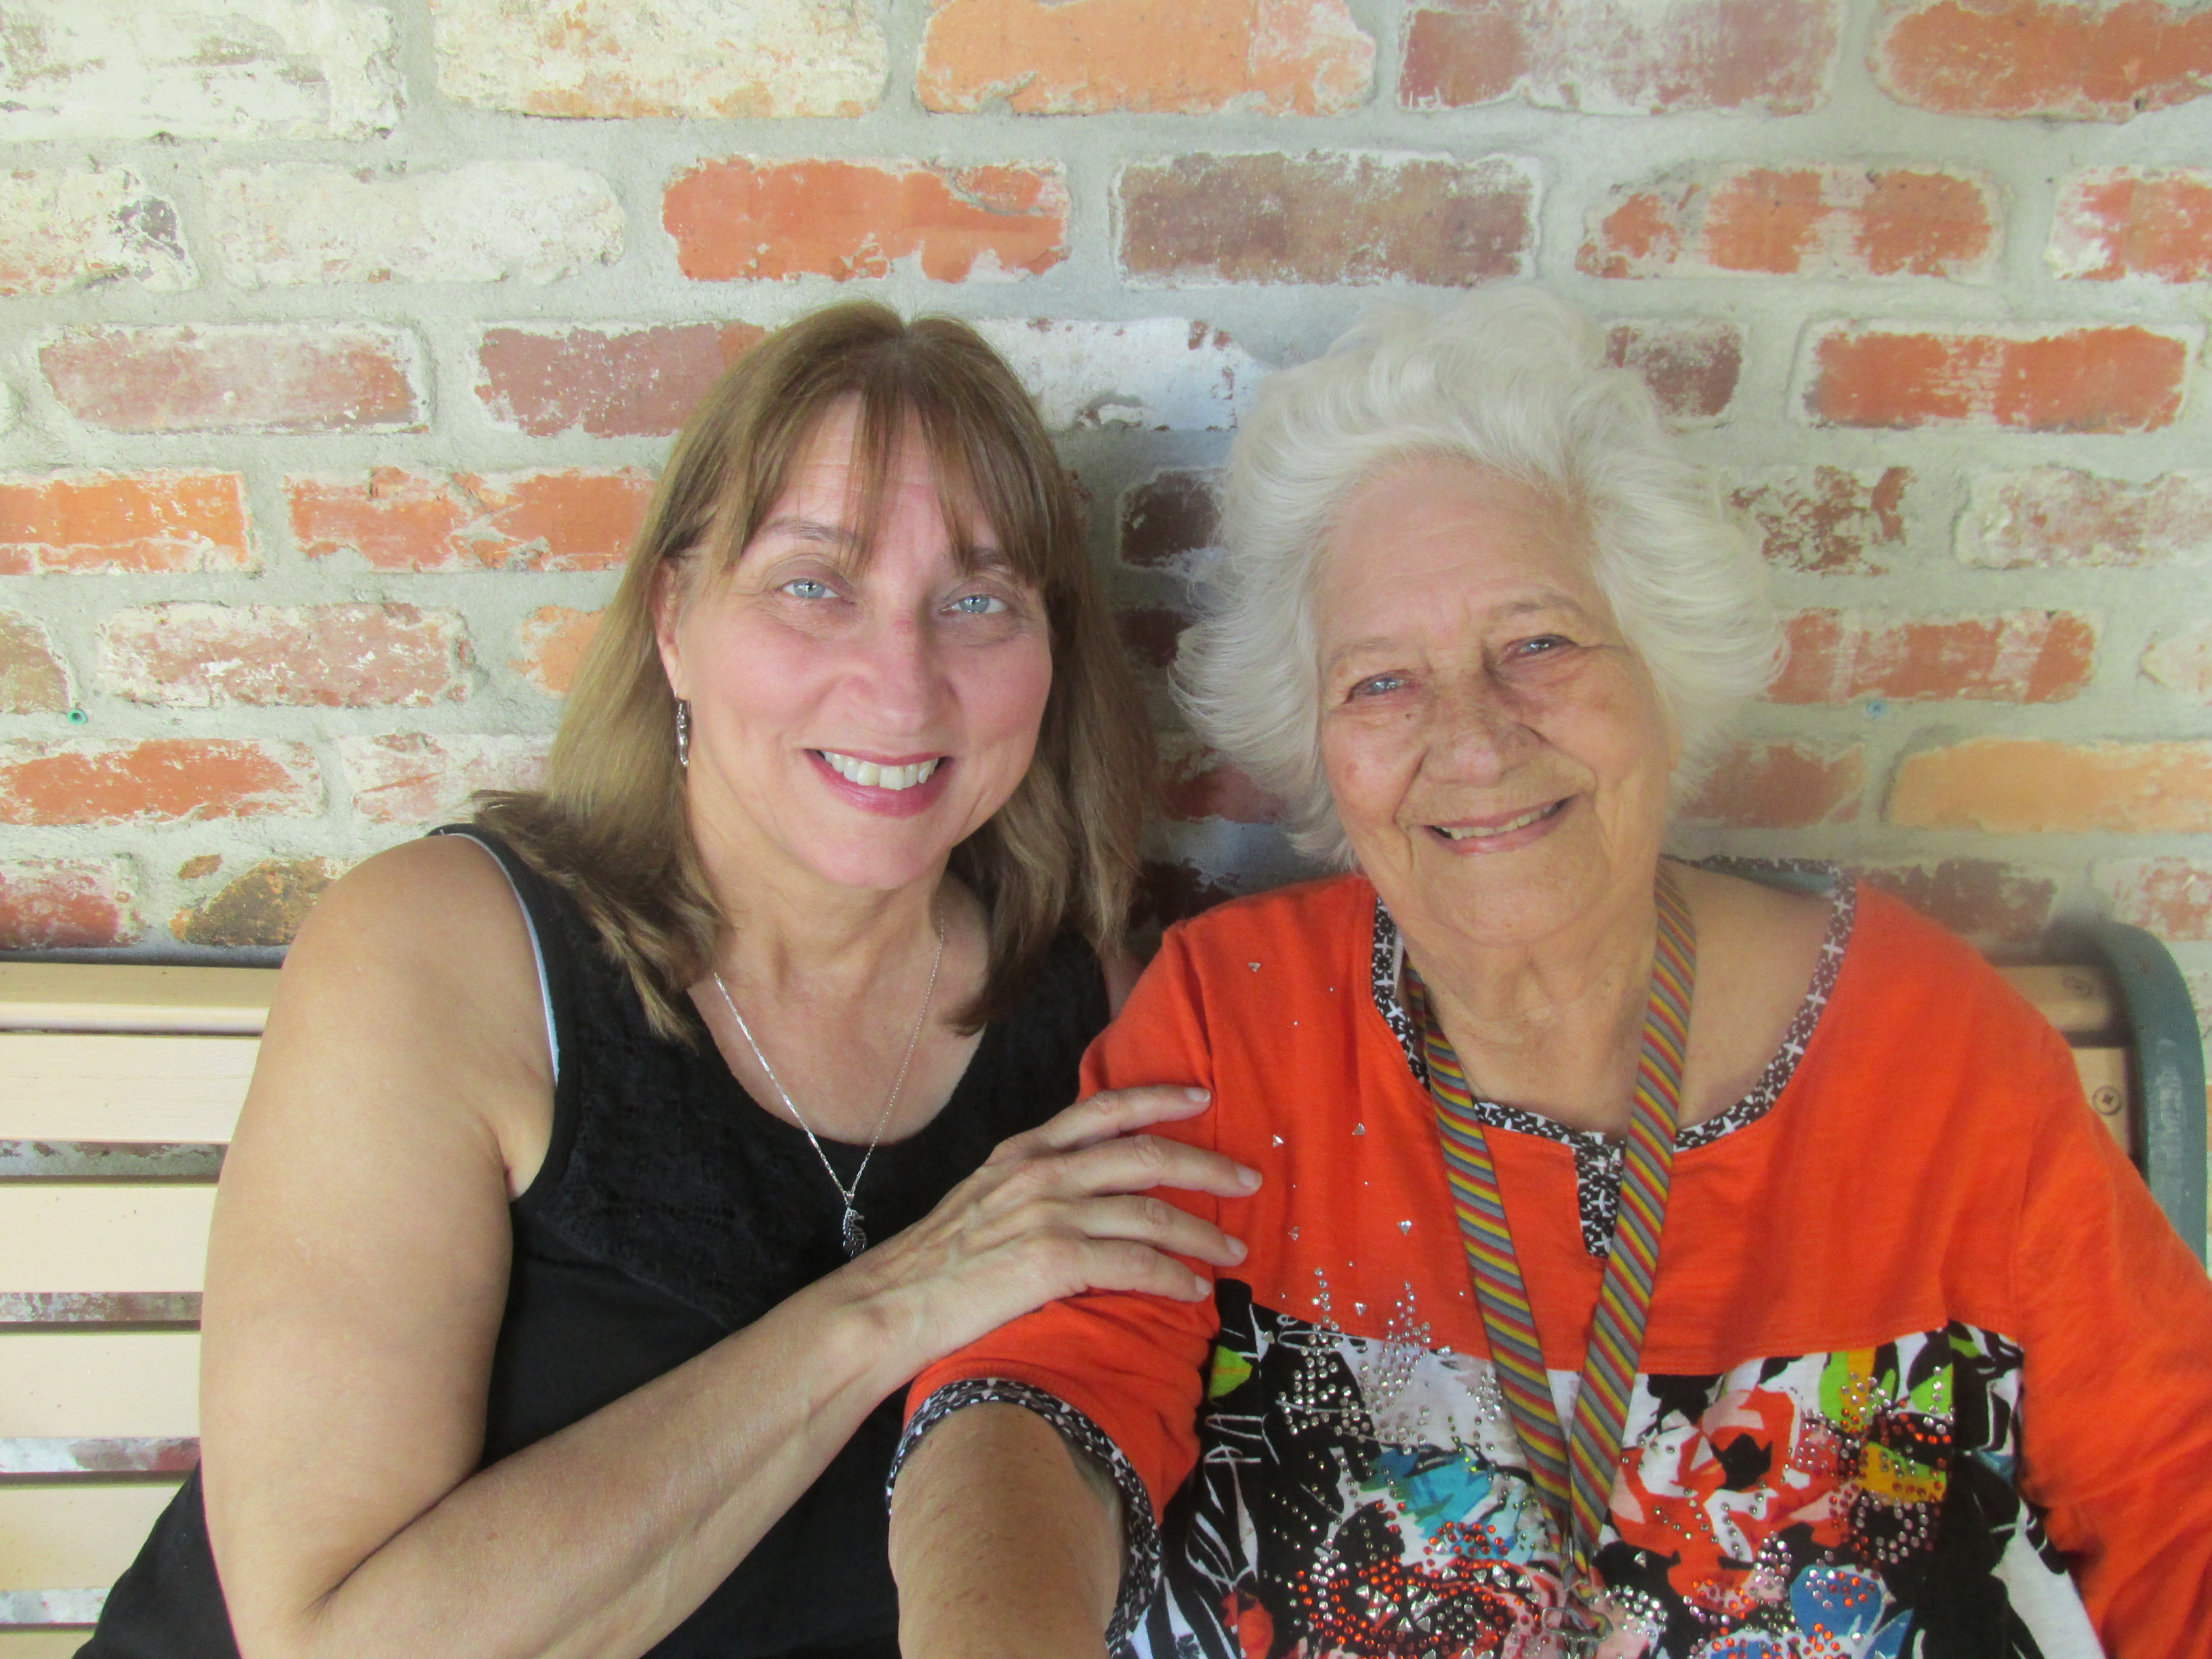

**Diane & Helen**

**14.** A bonus gift (“yapa,”as they say in Chile) was our recent visit with 94-year-old retired missionary, **Helen Prado**, in Dowling Park, FL. This dear lady has an amazing life story which Diane is in the process of writing. Thanks for praying that this little project might have a big impact.

***“Enjoy the little things in life, for one day you may look back and realize they were the big things.”*****Praise the Lord with us for a baker’s dozen of little gifts that were big blessings to us over the past few months: 1. The chance to work here at GMSA Florida headquarters with our co-workers, Raúl and Jane Villalba. 2. The Diaz family, Chilean friends who now live in south Florida. 3. Several visits with our daughters and grandchildren. 4. Being here to celebrate my Mom’s 80th birthday with a surprise party in Maine, along with my whole family! (See photo ☺ --I’m #1.) 5. Attending a Christian writers’ conference in Tennessee. 6. The memorial service for 104-year-old missionary, Nell Eggleston. 7. The super men’s and ladies’ retreats of Grace Baptist Church and the kindnesses of friends new and old here. 8. The many missionary visitors we’ve hosted here at the Fort over the past few months. 9. The many times we’ve been the recipients of the wonderful hospitality of others. It wouldn’t do to start naming and forget someone, but you folks know who you are. May God repay you! 10. The beauty of fall foliage in New England and Atlantic Canada. 11. A Canadian Thanksgiving brunch with Curtis’s family in Halifax. 12. Ten days at a friend’s cottage in Earltown, NS, and the Subway lunch at our home church in Truro. 13. A visit from Diane’s sister Cheryl in Florida.**